MZO Guide for First Nations
Contents
What is an MZO? 1
What are the concerns? 3
How widely are MZOs being used? 5
What projects are MZOs being used for? 5
Where do I find a specific MZO? 5
Who is supposed to fulfill the duty to consult and accommodate (DTCA) for an MZO? 6
How can I respond to an MZO notification? 6
Can I appeal an MZO? 7
What other action can I take? 7
Other Links and Resource 7

What is an MZO?
A Minister’s Zoning Order (MZO) is a provincial planning tool that allows the minister of Municipal Affairs and Housing (MMAH) to rezone a piece land to fast-track development, while bypassing public participation. The Planning Act has long afforded the Minister significant discretionary authority to directly zone land (under S. 47 of the Planning Act); however, the use of this extraordinary power was often limited to areas without municipal organization, cases of emergency or where there was a pressing provincial objective at stake. An example of an MZO being used in an emergency was when the Algo Centre Mall collapsed in Elliot Lake.
“Planning processes that often take months or years to complete because they ensure that sufficient due diligence is conducted through technical studies and public consultation are being bypassed by MZOs. Our audit found that MZOs were originally intended to be used only in special circumstances such as in areas with no municipal governance or to quickly advance provincial initiatives. However, since 2019, the Province has publicly indicated numerous times that the reason for issuing recent MZOs is to overcome potential barriers and delays to development. This approach treats the land-use planning process as a hurdle. In the two-year period from March 2019 to March 2021, 44 MZOs were issued. Prior to this, an MZO was issued about once a year.”- Auditor General of Ontario Report Land-Use Planning in the Greater Golden Horseshoe https://www.auditor.on.ca/en/content/annualreports/arreports/en21/AR_LandUse_en21.pdf
As referenced in the above quote, there has been a significant increase in the use of MZOs since 2020- “urgency” is being defined by the current government as anything to stimulate economic growth, justified by the COVID 19 pandemic and its impacts on Ontario’s economy.
Bill 257, Supporting Broadband and Infrastructure Expansion Act, 2021 made the following amendments to the Planning Act:
“The Planning Act is amended to provide that ministerial zoning orders made under section 47 are not required and are deemed to never have been required to be consistent with policy statements issued under subsection 3 (1).
However, any part of such an order that applies to land in the Greenbelt Area is and always has been required to be consistent with a policy statement issued under subsection 3 (1).”
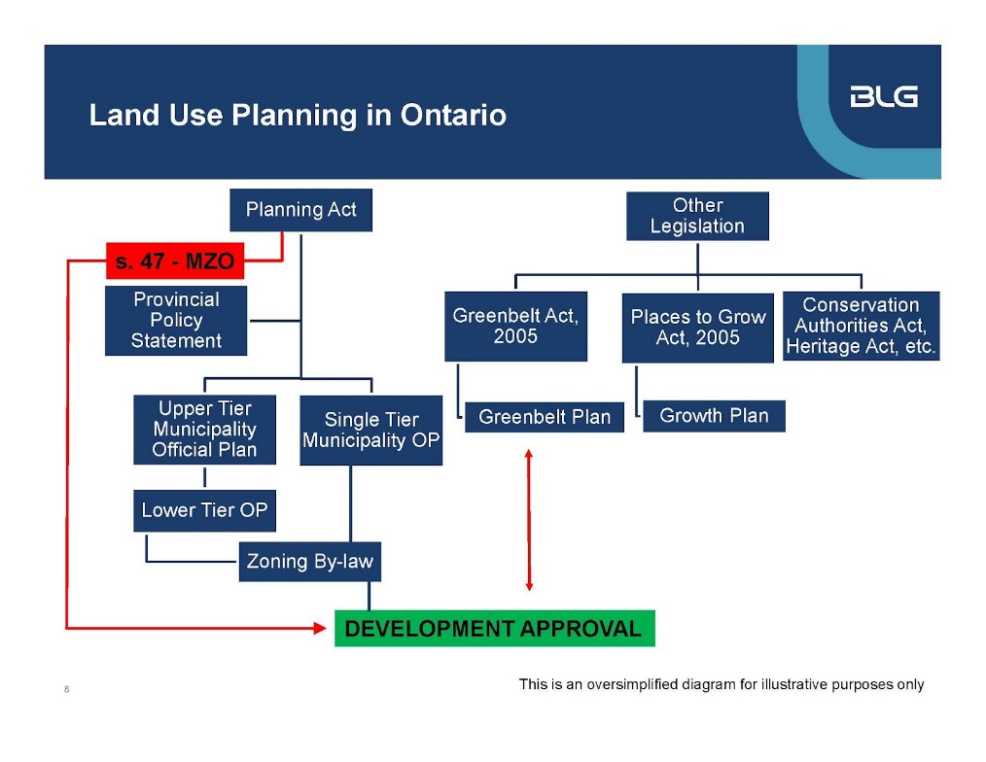
Similar to what is depicted in the above graph, MZOs bypass plans developed by communities and the Provincial Policy Statement (PPS) to get approval directly from the Minister of Municipal Affairs and Housing.

What are the concerns?
- Bypassing democratic processes
Typically, a person or municipality seeking to change a zoning by-law must adhere to the process set out in section 34 of the Planning Act and O. Reg. 545/06. This process provides for notice of the proposed amendment, public consultation and, generally, a right of appeal to the Local Planning Appeal Tribunal (the Tribunal).

In the case of an MZO, the Minister does not need to give notice or hold a hearing before issuing an order. There is also no appeal process. Traditionally, the MZO power was used sparingly and perhaps less frequently in more urbanized areas with mature planning regimes. With Bill 197’s expansion of the utility of MZOs, they are now being made most frequently for lands in municipalities that have well-established planning policies and protocols approved locally pursuant to the Planning Act, especially across southern Ontario. https://www.blg.com/en/insights/2020/11/ministers-zoning-orders-come-to-the-fore-in-a-pandemic

- No impact studies or reports
MZOs bypass the need for environmental assessments, which means studies on impact are not performed, going against cumulative impact assessment trends. No studies for environmental assessments = not informed consultation.

- No process to consult and accommodate Indigenous nations
An increasing number of First Nations are voicing opposition to MZOs because of lack of early and ongoing consultation and accommodation of Indigenous interests.
https://www.barrietoday.com/local-news/first-nations-group-challenging-mzo-granted-for-massive-orbit-proposal-in-innisfil-4472407
https://www.durhamregion.com/news-story/10278790-chiefs-of-the-williams-treaties-first-nations-oppose-pickering-development/
https://www.cbc.ca/news/canada/hamilton/mzo-indigenous-consultation-1.6433671
https://www.thestar.com/news/gta/2021/11/15/indigenous-group-launches-legal-action-over-ford-governments-use-of-mzo-to-fast-track-development.html

We believe that the MZO process is not consistent with the Duty to Consult and Accommodate established by the Supreme Court of Canada and enshrined in Section 35 of the Constitution Act, 1982 that affirms existing Treaty and Aboriginal Rights. Also, see section: Who is supposed to fulfill the duty to consult and accommodate for an MZO?

- Undermining the Provincial Policy Statement (PPS)
Because MZOs don’t have to comply with the PPS, they also undermine the work that has been done strengthened its language around Indigenous consultation and engagement, specifically:
- Part IV -Vision: Indigenous perspectives, Aboriginal communities, & meaningful engagement
- Section 1.2 -Co-ordination: Planning authorities shall engage with Indigenous communities and coordinate on land use planning matters
- Section 2.0 -Wise Use: Ontario's long-term prosperity, environmental health, and social well-being depend on: biodiversity conservation, health of the Great Lakes, & protecting natural heritage, water, agricultural, mineral, and cultural heritage & archaeological resources
- Section 2.6 Cultural Heritage and Archeology: Planning authorities shall engage with Indigenous communities and consider their interests when identifying, protecting and managing cultural heritage and archaeological resources
- Section 4.0 Implementation: Consistent with Section 25 (rights under The Royal Proclamation, 1763) & Section 35 (Aboriginal and Treaty rights) of the Constitution Act, 1982

- Not consistent with principles of UNDRIP
The MZO process is not consistent with the aspirational principles outlined in the United Nations Declaration on the Rights of Indigenous Peoples (UNDRIP) including:
- a) relationship with and access to the lands and resources traditional to their communities.:
- b) and Free, and Prior, and Informed Consent regarding activity within these traditional territories (FPIC).
- Undermining Truth and Reconciliation efforts
This process ignores TRC recommendations like Call to Action #52 that governments accept Aboriginal title over land and that the burden of proving any limitations on these rights shifts to those who assert that such limitations exist

How widely are MZOs being used?
There is a large cluster of MZOs being used in the GTA, but there are also a couple around Barrie, Kingston, as far south as Niagara Falls and as far north as Sault Ste. Marie. The linked map below shows all MZOs (that we know of).
https://yourstoprotect.ca/ministers-zoning-order-map/

What projects are MZOs being used for?
Here are some examples:
Transit hub in Innisfil: https://globalnews.ca/news/8100902/innisfil-ontario-orbit-transit-hub-mzo/
Warehouse in Cambridge: https://www.therecord.com/news/waterloo-region/2022/03/11/cambridge-council-to-make-final-decisions-about-controversial-mzo-driven-warehouse.html
Warehouse in Pickering : https://ecojustice.ca/case/fighting-to-protect-important-wetlands-duffins-creek/
https://www.tvo.org/article/the-rise-and-fall-of-the-duffins-creek-mzo
Quarry in Guelph: https://guelph.ca/living/environment/our-community-our-water/a-short-history-of-guelph-and-dolime-quarry
Medical facility in Oro-Medonte: https://www.simcoe.com/news-story/10585806-oro-medonte-property-pulled-off-the-market-status-of-mzo-uncertain/
Housing in Vaughn: https://www.yorkregion.com/news-story/10513088-developers-behind-vaughan-mzo-that-promised-10-affordable-units-drop-their-vow/
Housing in Toronto (requested MZO): https://www.cbc.ca/news/canada/toronto/ontario-mzo-willowdale-modular-housing-1.6339477
https://environmentaldefence.ca/2022/04/05/three-shady-ministers-zoning-orders-in-ontario/

Where do I find a specific MZO?
If you are looking for the specific Ontario regulation that approved an MZO, visit https://www.ontario.ca/search/ontario-gazette and search for the name of the municipality for which the MZO was issued, or search by date and key words “zoning order”. Click on the hyperlinked Publications under Part III (Regulations) of the Legislation Act, 2006 to see all regulations made for that date.

Who is supposed to fulfill the duty to consult and accommodate (DTCA) for an MZO?
The Minister has publicly stated that he expects that before a municipality requests an MZO it does its due diligence, which includes consultation in their communities, connecting with conservation authorities and engaging with potentially-affected Indigenous communities. The Minister has publicly stated that MZOs granted on non-provincially owned land are made at the request of the local municipality.
The Association of Municipalities of Ontario, however, disagrees that municipalities are responsible for the DTCA: “As mentioned, Ontario has taken a position that municipalities have a Duty to Consult in some circumstances. The province has gone as far as to assert that municipal governments in Ontario have an independent responsibility for the Duty to Consult. As put forward in this discussion paper, AMO respectfully disagrees with this long-standing provincial position.” https://www.amo.on.ca/sites/default/files/assets/DOCUMENTS/Reports/2019/MunicipalGovernmentsandtheCrownsDutytoConsult20190410.pdf
Bill 109 - adds non-delegation clauses https://www.ola.org/en/legislative-business/bills/parliament-42/session-2/bill-109

How can I respond to an MZO notification?
Contact the municipality that requested the MZO as well as the MMAH. Ask questions like:
What is the rationale for issueing a MZO for this project? “It is our understanding that this planning mechnism is intended to only be used in special circumstances and that it bypasses due diligence normally conducted through technical studies and public consultation.”
Have there been any attempts to engage First Nations or the Métis Nation? “It is important to us that we are consulted and accommodated on the potential impacts on our asserted or established Aboriginal or treaty rights.”
Have technical studies and/or reports been undertaken that could be shared? “That being said, we require more information to assess potential impacts on our rights. We note that without critical information provided through technical studies it is impossible to assess the potentail impacts of this project on our rights.”
What is the timeline? “We would also welcome a meeting. Please review our consutlation protocols [linked or attached] and our fee schedule [linked or attached] in advance.”
Other important messages to emphasize:
- Notification does not constitute consultation.
- A lack of response to notifications and other communications does not indicate consent.

Can I appeal an MZO?
No, MZOs are not subject to appeal.

What other action can I take?
There are coalitions and partnerships being formed to fend off MZOs. Recognize that each group may have their own priorities, but if you are fighting an MZO development there may be organizing/supportive resources available
Contact the municipality requesting the MZO as well as the Ministry of Municipal Affairs and Housing to voice your concerns.
A judicial review (a process by which courts make sure that the decisions of administrative bodies are fair, reasonable, and lawful) is ongoing for the Duffins Creek MZO.

Other Links and Resource
Basic intro to MZOs: https://www.youtube.com/watch?v=Efxyqz-WGlk
More detailed history of MZO: https://www.mondaq.com/canada/construction-planning/1008660/minister39s-zoning-orders-come-to-the-fore-in-a-pandemic-
https://www.blg.com/en/insights/2020/11/ministers-zoning-orders-come-to-the-fore-in-a-pandemic
Ontario Nature’s concerns and campaign: https://ontarionature.org/campaigns/mzos/

